File Types

Spec:
In this project, we will use inheritance, function overloading, and file output in order to create and output files of different file types - .txt, .csv, and .html.

The text file (.txt) will be the parent class, while .csv and .html will inherit from .txt. They will have a series of shared functions. No matter whether you declare a variable as a TextFile, CsvFile, or HtmlFile, the same set of functions will work and output correctly.

Classes
The classes should look like:

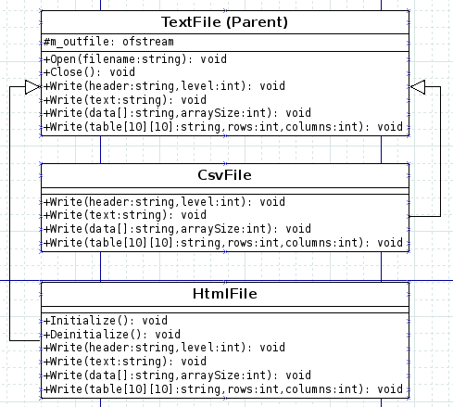

m_outfile

A protected ofstream object, which is our output file. Protected members are accessible by the class' children, but not by outside objects.

void Open( string filename )

This will open m_outfile to the given filename

void Close()

This will close m_outfile

void Initialize()

Only in HtmlFile

Each document will have different ways to Initialize its file. For example, we will put some basic CSS in the HTML file.

void Deinitialize()
Only in HtmlFile

Each document will have different ways to Deinitialize its file. For example, with the HTML file we need to add a </body> at the end.

void Write( string header, level int )
overridden

This is our way of writing a header for the document

void Write( string text )
overridden

This will write a simple line of text in the document

void Write( string data[], int arraySize )
overridden

This will be how we output a list of information

void Write( string table[10][10], int rows, int columns )
overridden

This is how we will write a 2D table to our document. The max size of the table is 10x10, but can be smaller (must have rows/columns dimensions specified)

Text File format
Type: Normal Text
Function: void Write( string text );
Output:
Output the text with a newline at the end (endl)

Type: Header
Function: void Write( string header, int level );
Output:
Append pound-signs before displaying the header text; you will have one # for each level.
Example:
# Header1
## Header2

Type: List
Function: void Write( string data[], int arraySize );
Output:
Display each list element on its own line, with a “*” before the item.
Example:
* Item 1
* Item 2

Type: Table
Function: void Write( string table[10][10], int width, int height );
Output:
Use two for-loops to iterate through every element of the table. Elements in a row should be separated by pipes “|”, while separate rows should just get new lines:
Example:
Item 1 | Item 2
Item 3 | Item 4

CSV File format
Type: Normal Text
Function: void Write( string text );
Output:
Output the text with a newline at the end (endl)

Type: Header
Function: void Write( string header, int level );
Output:
Append pound-signs before displaying the header text; you will have one # for each level.
Example:
# Header1
## Header2

Type: List
Function: void Write( string data[], int arraySize );
Output:
Display each list element on its own line.
Example:
Item 1
Item 2

Type: Table
Function: void Write( string table[10][10], int width, int height );
Output:
Use two for-loops to iterate through every element of the table. Elements in a row should be separated by commas “,”, while separate rows should just get new lines:
Example:
Item 1,Item2
Item 3,Item4
When opened in Excel, commas separate columns and newlines separate rows.

HTML File format
Type: Normal Text
Function: void Write( string text );
Output:
Output the text between paragraph tags
Example:
<p>This is the text I entered</p>

Type: Header
Function: void Write( string header, int level );
Output:
Output the text between header tags of the appropriate level.
Example:
<h1>Main header</h1>
<h2>Sub header</h2>

Type: List
Function: void Write( string data[], int arraySize );
Output:
Each item in a list will be contained within list-item tags <li> … </li>, while the entire list will be enclosed within unordered-list tags <ul>...</ul>
Example:
<ul>
<li>Item 1</li>
<li>Item 2</li>
</ul>

Type: Table
Function: void Write( string table[10][10], int width, int height );
Output:
A table will be enclosed in table tags <table> … </table>, with each row contained in table-row tags <tr>...</tr>, and each cell in table-data tags <td>...</td>
Example:

<table>
<tr>
<td>Row 1 Column 1</td>
<td>Row 1 Column 2</td>
</tr>
<tr>
<td>Row 2 Column 1</td>
<td>Row 2 Column 2</td>
</tr>
</table>

HTML special Initialize function:
After the HTML file is opened, the Initialization function will need to be called. It will contain this code:
void HtmlFile::Initialize()
{
m_outfile << "<head>" << endl;
m_outfile << "<style type='text/css'>" << endl;
m_outfile << "body { background: #a6e8f8; font-family: 'Arial'; }" << endl;
m_outfile << "p { color: #070764; font-weight: bold; }" << endl;
m_outfile << "table { width: 300px; }" << endl;
m_outfile << "table tr td { border: solid 2px #3a7eb8; }" << endl;
m_outfile << "</style> " << endl;
m_outfile << "</head>" << endl;
m_outfile << "<body>" << endl;
}

This sets up a bare-bones HTML header with some simple CSS styling.

HTML special Deinitialize function:

Before the Close() function is called, the Deinitialization function will need to be called for HTML Files.
void HtmlFile::Deinitialize()
{
m_outfile << "</body>" << endl;
}

This closes the <body> tag that was opened during Initialize(). All the text content written to the webpage is enclosed within the body tags.

Runner Program

See main.cpp within the Assignment 4 folder to get an idea of how the document classes will be used and outputted to. You can also use it to test with.

Dates:
Assigned: 2013-06-27 Thursday
Due: 2013-07-11 Thursday at 11:59 pm

During the week of the 4th we have a midterm exam and the 4th of July. You will have two assignments “in flight” at the same time (Assignment 3 and Assignment 4), but they're both relatively small.
Assignment 3 is due Tuesday, Assignment 4 is due Thursday of Week 5. Please work on them both during Week 4.

Make sure that your source code is committed and synced to your student GitHub account. You do not need to turn in the code via Blackboard or anything else.

